SAVE THE DATE
SAFS Meeting 2016 Sarasota 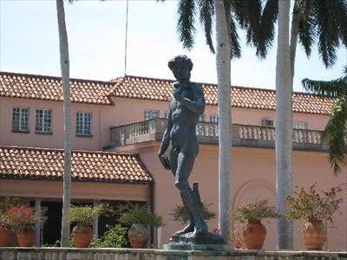
September 25- October 1
Hyatt Regency on Sarasota Bay
For more information call Nancy Ludwigsen (941) 861-4707 or email nludwigs@scgov.net

